**TABLE OF CONTENTS**

**Introduction………..………………………………………………..….……….…… 2**

**Scope of the system…....………………………………………..…………….…. 2**

**Features ….………………..……………………………………………….…..…..…. 3**

**Recommendation……………………….……………...…………………...…..…. 3**

**WEB……..…………………………………………………….………………..………. 4**

**Conclusion……………..……………………………………………………..………. 4**

**INTRODUCTION**

The CAL COUNTER is an app which will be beneficial to those who are very conscious about their health. By this app they have an eye on their calories intake. The app will save their calories intake with date and time and which food they have been eaten also will be save in SQLite database so the user can look his or her previous food intake. The app will be more efficient to patients and physician by CAL COUNTER will notify patient and physicians by hazards of intake more than recommended. Cal Counter will send food intake of patient or any person to their loved ones and physician by Bluetooth, Wi-Fi, Gmail or any other medium of social network such as Facebook and twitter.

**SCOPE OF THE PROJECT:**

CAL COUNTER is a app which will be beneficial for patient’s physician and diet conscious who are more concern about their diet and food. The app will notify user about their diet and food which they have taken and show them on a mobile screen and save it in database the user can send their calorie intake to physician and other users by Gmail or any other medium of communication.

The CAL COUNTER is an app which will be beneficial to those who are very conscious about their health. By this app they have an eye on their calories intake. The app will save their calories intake with date and time and which food they have been eaten also will be save in SQLite database so the user can look his or her previous food intake. The app will be more efficient to patients and physician by CAL COUNTER will notify patient and physicians by hazards of intake more than recommended. Cal Counter will send food intake of patient or any person to their loved ones and physician by Bluetooth, Wi-Fi, Gmail or any other medium of social network such as Facebook and twitter.

**FEATURES:**

**Food name save in database.**

**Calorie of food will be save in database.**

**Show saved values on screen.**

**User can send his info to physician.**

**User can delete food intake.**

**App will show total calorie intake.**

**The proposed system has the following capabilities: -**

**Main Activity:**

This App starts and the first page of app will be appearing where user can insert food name and calorie and hit submit button.

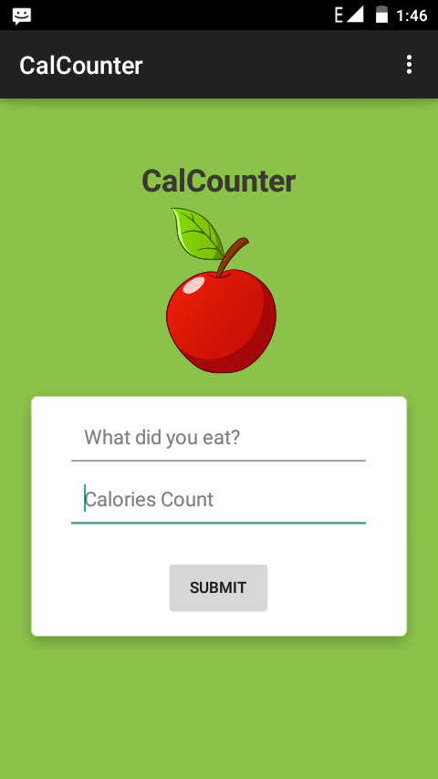

**Display Food Activity:**

This screen will show dial of all food saved in database to user.

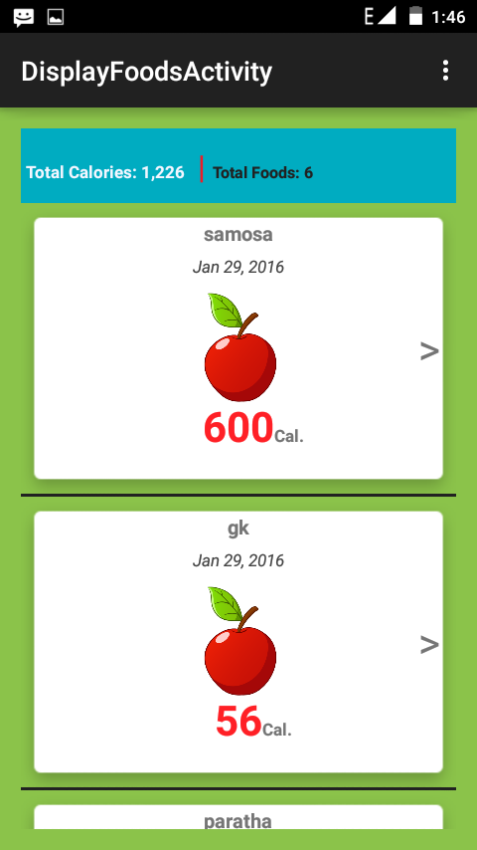

**Item Detail Activity:**

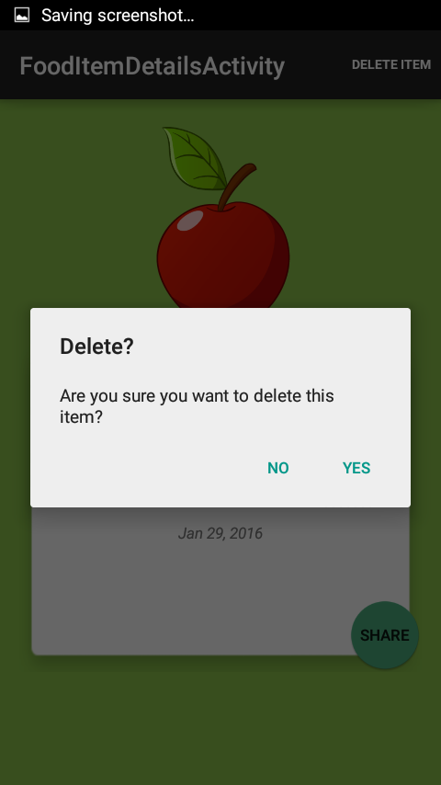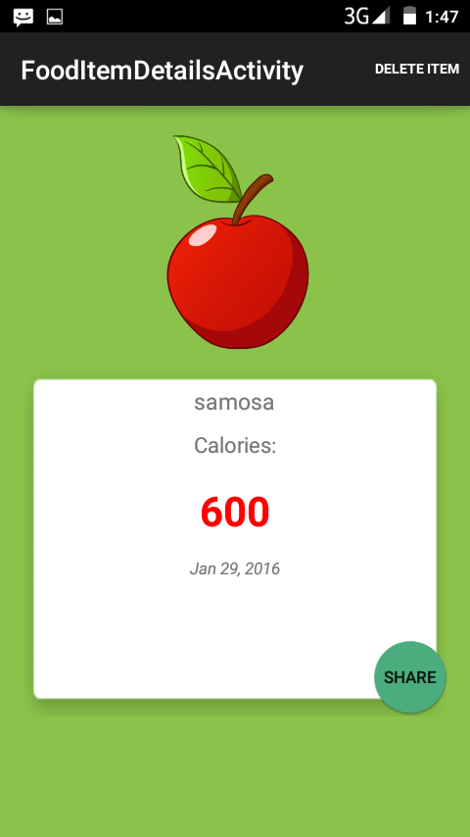In the main page control panel there we can control our application and choose what level to be indicate. And we can give a feedback about the system.

**Send Info Activity:**

In this form the user enters his information and comments about the system working and reliability and also he can submit any error about the system in this feedback form and save it in the feedback table.

